International Organizer Norm Report Form IO1

organizer’s last name:  Rivero Gómez | first name:  Josep Antoni |  |  | code (if any):  6900437
date of birth:  10/11/1971 | place of birth:  Ourense (ESP) |  |  | federation:  AND
federation, where event took place:  AND |  | name of event:  33 Open Andorra Hotel St.Gothard
dates:  18/07/2015 - 26/07/2015 | venue:  ERTS - LA MASSANA |  | type of event:  SUIZO
number of players:  166 | number of FIDE Rated players:  157 |  |  | number of rounds:  9
number of federations represented:
18

Confidential Report: (Comments of Chief Arbiter. Should this be inappropriate, the form should be signed by a suitable person who is qualified. These comments should refer to the Organizer’s conduct of the event in accordance with FIDE standards)

- Mr. Rivero organized a very nice Tournament.
- The venue was excellent and the playing area was big enough not to disturb the players.
- Playing conditions were excellent for the level of the Tournament
- Everyday information of the tournament was sent to local newspapers and was published in the Internet.

Recommendation: The organizer’s standard was that required of an International Organizer.

name: IA Juanjo Escribano Lasa (FIDE ID 2282631)

position: CHIEF ARBITER
date: 26/07/2015

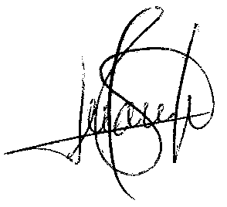
Signature

